MINISTRY OF GENERAL EDUCATION
I/SCIENCE LESSON PLAN
NAME OF TEACHER:________________________ SCHOOL:_____________________
GRADE | TOPIC | SUB TOPIC | DURATION | DATE
9 | LIGHT AND ITS NATURE | TYPES OF LENSES | ____min | ____/___/__
ATTENDANCE: Boys:______ Girls:_______ Total:_____
TEACHING/ LEARNING AIDS : Models, Chalk board, Learners books and Charts.
REFERENCES : I/Science Progress book 9, Study kit I/Science Pamphlet
RATIONALE: This is lesson number one on Light and Nature in the series of three. It will help learners acquire skills and values of identification of the different types of lenses. Group work, discussion, demonstration and Question & Answer methods will be used to execute the lesson.
PRE-REQUISITE SKILLS/ KNOWLEDGE: learners have prior knowledge on the Light.
SPECIFIC OUTCOMES, LSBAT:
- Describe the different types of lenses
- Demonstrate the location of the focal point and focal length of a lens
- Explain the mechanism of a converging lens to produce real and virtue images
STAGE | CONTENT | TEACHERS ACTIVITY | PUPILS ACTIVITY | METHODS
INTRODUCTION  ____min | Recap on previous lesson  - CHEMICAL REACTION  A chemical reaction is one where a new chemical substance is formed from the original substance. | Teacher asks random questions | Pupils listen and participate | Brainstorm
D  E  V  E  L  O  P  M  E  N  T  ___min | The different types of lenses  A Converging lens is also known as a convex lens. It is thicker in the middle and thinner at the edges. It makes parallel light rays passing through it to bend inwards and meet (converge) at a point.  Converging lens  Concave lens  A concave lens is also known as a diverging lens, is thicker at the edges and thinner in the middle. This lens makes a beam of parallel light rays passing through it to diverge (or bend as it spreads outwards) from a point.  Experiment  Demonstrate the location of the focal point and focal length of a lens  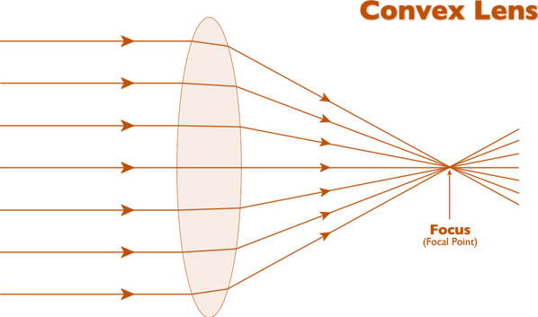  Optical center  Principal axis  Focal length  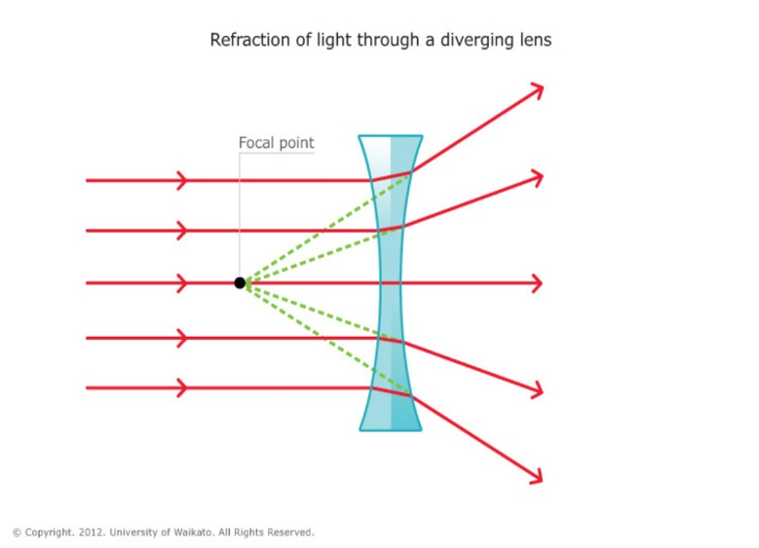The distance between the focal point and the centre of the lens ( or focus of the lens ) is called the focal length.  Focal length  Principle axis  Optical center  The principal focus or focal point is the point at which rays parallel to the principal axis either converge or appear to be diverging after refraction or reflection through the lens. | Teacher explains the details to the learners  Teacher puts pupils in groups to discuss  Teacher writes brief notes on the board | Pupils listen and ask questions  Pupils discuss and bring out points  Pupils copy the notes in their note books | Teachers  Exposition  Group  work  Individual work
PRACTICAL ACTIVITIES
- Demonstrate the location of the focal point and focal length of a lens
TEACHER/ PUPIL’S EVALUATION………………………………………………………

